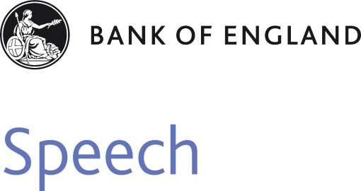

**Climbing the Public Engagement Ladder**

Speech given by

Andrew G Haldane Chief Economist Bank of England

Royal Society for the encouragement of Arts, Manufactures and Commerce (RSA) 6 March 2018

The views expressed here are not necessarily those of the Bank of England or the Monetary Policy Committee. I would like to thank Shiv Chowla for his help in preparing the text. I would like to thank Michael Anson, Ben Broadbent, Mark Carney, Clare Macallan, Emma Murphy, Jennifer Nemeth, Mette Nielsen, Dave Ramsden and Ratidzo Starkey for their comments and contributions.

I am delighted to be here to discuss the final report from the RSA Citizens’ Economic Council on “Building a Public Culture of Economics”. This is the culmination of a two-year project, working with around 250 citizens and a number of organisations from across the country, including the Bank of England. I would like to congratulate Matthew Taylor, Chief Executive of the RSA, and Reema Patel, Kayshani Gibbon and

Tony Greenham from the RSA as leaders of the project, for their terrific work in pulling this together. It is an impressive, progressive and ambitious agenda for the economy and for economic policymakers like me.

Of course, citizens *do* already have a crucial stake in the economy. As economists we often divide the world into neat institutional packages – companies, governments, trade unions, charities. While useful organisationally, these names are no more veils, part legal, part social. Behind the veil lies the ultimate owner – citizens, whether as workers, customers, shareholders, stakeholders or voters. Institutions are executive gatekeepers of these citizen democracies. Ultimately, it is citizens to whom policymakers, economic and otherwise, are accountable. Those of us in the policy game need never to lose sight of that.

Despite those ownership rights, it is nonetheless the RSA’s contention that citizens are not at present engaged in the economy, and in economic policy, as fully as would be desirable. They make the case for moving to a *deliberative democracy*, one in which citizens have a greater say on matters economic and financial. This is a big contention. Nonetheless it is one that I – as a citizen and as someone who works for one of those institutional veils, the Bank of England – fully accept. More than that, the Bank is making strides towards increasing citizen engagement in the economy and understanding of economic policy.

In what follows, let me first say a word about the aims and objectives of a programme of citizen engagement, the like of which the RSA are proposing – the “ends”. I will then turn to the “means” – what practically could be done, and indeed is being done, to improve citizen engagement with the economy and economic policy. For reasons of familiarity, I will focus on Bank of England initiatives as one example of such public engagement, although the RSA’s recommendations cover a range of other policymaking functions.

# The Ends

So what could we hope to achieve by increasing citizens’ engagement with issues of economics and finance? My short answer to that question is a great deal. Economics, and economic policy, faces a “twin deficits” problem – a deficit of public *understanding* and a deficit of public *trust*.1 Twin deficits, be they fiscal and external or trust and understanding, carry dangers for the economy and for economic policy. Closing them would, I believe, deliver significant benefits to society, to individuals and to policymakers who sit twixt the two. Here’s why.

Let’s take public understanding of the economy. As the public themselves would be the first to admit, this is not high and not as high as we would wish. On economic and financial matters, there is often a yawning

1 Haldane (2017a).

understanding deficit on the part of the general public. That is not because the public are yawning at the prospect of engaging with these issues. To the contrary, surveys regularly show that a significant majority recognise the importance of economic and financial issues to their everyday lives. Around 80-90% say they would like economic and financial issues to be covered more comprehensively in the school curriculum.2

It would be wrong, however, to think that public engagement only benefits the *public*. Just as important are the improvements to policymakers’ understanding of everyday economic issues. There is now a wide body of evidence, drawn from a wide variety of settings, on the benefits of combining the insights from expert and non-expert sources when making sense of a complex world, when forecasting an uncertain future.3 Harvesting insights from a non-expert audience appears, in these uncertain settings, to be especially valuable by providing diverse perspectives and different insights.

If we turn from understanding to trust, the picture has many similarities. Trust lies at the heart of the social contract between institutions and societies, between policymakers and citizens. But the very nature of trust appears to have changed rather fundamentally over the recent past. Societies and individuals have undergone what Rachel Botsman in her recent book calls a “trust shift”.4 Where once trust was institutionalised and anonymised, today it is socialised and personalised.

This shift in the gears of trust has had consequences. Public institutions of all stripes have been one of the casualties, with measured trust having fallen steadily over the recent past.5 Most central banks have not escaped these shifting sands, in particular since the global financial crisis. For them and us, the age of innocence, or at least the era of taking public trust as given, may be over.

That matters. Credibility and trust are the secret sauce of central banking. They are what enable them to shape expectations in ways which stabilise the economy and financial system. An economy or financial system without trust, history tells us, ceases to be a system. An economic or financial policymaker without credibility, history tells us, ceases to be a functioning policymaker. Removal of the veil, breaches of the social contract, leaves the economy and financial system vulnerable.

There is no single measure, nor quick fix, for closing these twin deficits with the general public. The supply chain for secret sauce, of building and restoring trust and understanding, is long and arduous. Nonetheless, it seems clear that increased engagement between policymakers and wider society is a necessary ingredient for its manufacture. From other spheres, such as medicine, we know that trust and understanding are built on everyday engagement. For the Bank of England, with the scars of the financial crisis still healing, the case for continuing to build those foundations is strong.

2 Haldane (2017a). The RSA call these benefits improved “agency” among citizens.

3 Tetlock and Gardner (2016). The RSA call these benefits improved “efficacy” of policymaking.

4 Botsman (2017).

5 See, for example, the Edelman Trust Barometer. The RSA call these benefits improved “legitimacy” of policymaking.

# The Means

If the case is strong, how best is this citizen engagement to be achieved? The RSA report provides a nice framework for addressing this question. This is based on the “ladder of participation” model, devised originally by Sherry Arnstein in the late 1960s.6 The rungs of the engagement ladder are, in ascending order: inform; consult; involve; collaborate; and empower. As we move up the ladder, we increase the degree of citizen engagement in decisions that affect them. The RSA stop short of recommending the top rung, but do propose various initiatives to increase citizen involvement and collaboration.

Armed with this framework, I have been thinking about how far the Bank of England has so far climbed the citizen engagement ladder. Truth be told, I suspect for the first 300 years of its life, the Bank of England scarcely had its foot on the first rung. It saw little need even to inform the wider public about the economy and policy. Trust among the public was anonymised, institutionalised and given. When tempted to step up a rung, the Bank quickly contracted an acute form of vertigo.

Over the past 25 years the Bank has taken significant steps up the engagement ladder, in part in response to the public’s trust shift, in part reflecting the Bank’s wider policy responsibilities. These steps have transformed how the Bank “informs” and “consults” the public on its views and policies.7 One simple diagnostic is the rise in the Bank’s publication count. Seventy years ago, the Bank published precisely one speech a year. Today, rarely a day passes without multiple publications. Then, the Bank uttered publically fewer than 5,000 words per year. Last year, it uttered in excess of 4 ½ million.

Over the past two decades, it would not be an exaggeration to say there has been a genuine revolution in central bank communications. Perhaps even more importantly, there has been a revolution in central bank *attitudes* towards public engagement. This revolution has, with luck, increased the public’s understanding of the economy and economic policy. But there is no question in my mind that it has also enhanced very significantly central banks’ own understanding of the economy. Having ascended some rungs of the engagement ladder, our panorama on the economy has been much enhanced.

Looking back over the past five years, and looking forward to the next five, the Bank is taking further steps towards securing a foothold on the next rungs of the engagement ladder. This will increase the extent to which we “involve” and “collaborate” with a wider set of citizens, as well as “informing” and “consulting” them. From a potentially long list, let me highlight four examples of how we are going about that.

6 Arnstein (1969).

7 Haldane (2017b). A number of excellent historical examples are given in Kynaston (2017).

1. *Layered Communications*

There is a natural temptation among technocrats to communicate in a language that is only understood by fellow technocrats. This tendency has deep sociological roots, most probably dating back to our

hunter-gatherer past. At that time, language was a means of bonding and binding people; it was social glue. It still is. Language can also, however, be a barrier to understanding and, as in our hunter-gather past, a source of tribal conflict. These linguistic barriers apply everywhere and to everyone. But they seem to be especially troublesome among the economic and financial tribe, which stand out relative to others in their insularity.8

Central bankers are not immune to these primordial tendencies. They, too, sometimes use the tribal language of technocracy. And this too can sometimes serve as a barrier to understanding and a blockage to trust. My “stylised fact” (itself a piece of technical jargon) is that around 95% of all the words central banks utter are inaccessible to around 95% of the population. (Imagine speaking 4 ½ million words and more than 4 ¼ million of them falling on deaf ears?) If you conduct a semantic analysis of central bank text, you will find that I have erred on the side of generosity with these fractions.9 When someone says to me “spoken like a true central-banker”, they come to bury Andy not praise him.

But things are changing. The Bank is making a big effort to simplify and demystify its words and to challenge its ideas and thinking. The Bank’s staff blog, *Bank Underground*, is one example of such challenge. Last year, it recorded its millionth hit. Recently, the Bank has begun issuing its publications in a “layered” format, to cater for different audiences: a one-sentence, one-graphic version for the time-poor; a 60-page

chart-tastic technical text for the masochist. As best we can tell, this has opened up the Bank’s views to a far-wider audience. The number of website hits has increased markedly since publication of our first layered *Inflation Report* in November last year.

Recently, we have tried to pinpoint more precisely the benefits of layered communication in boosting the public’s understanding and trust. This involved conducting a so-called “randomised control trial” on two groups – a group of experts (students studying economics at university) and a group of non-experts.10 Both groups were randomly split with some given layered, and others un-layered, Bank of England content from the *Inflation Report*. This enabled a direct assessment of the impact of layering on understanding and trust.

It would have been a tad disappointing if layering had had no impact. And thank heavens for small mercies that, for both the expert and non-expert groups, layering boosted reported trust and understanding scores. What was more interesting was by *how much* layering seemed to help. In our sample, the boost to understanding of the economy and monetary policy that came from layering the *Inflation Report* was larger

8 Haldane and Turrell (2017).

9 Haldane (2017b).

10 Haldane and McMahon (forthcoming).

than the boost to understanding that came from having studied for an advanced degree in economics. That’s a depressing statistic for those of us who have studied economics, but great news for everyone else.

1. *Educational Programme*

A second strand of the Bank’s engagement strategy is education. You could see this initiative as helping to meet citizens’ self-expressed desire for firmer educational foundations on all matters economic and financial. To help dig the footings of that foundation, the Bank will be visiting around 200 schools this year to give talks and lectures using its newly-enlisted ambassador army, some with the help of our partner, the charity *Speakers for Schools*. The Bank also now runs two schools competitions, the most recent announced just last week in partnership with the *Financial Times*.11

The most significant of the Bank’s educational initiatives will take place in the classroom itself. We have developed, in conjunction with *We Are Futures,* classroom materials for use in the Personal, Social, Health and Economics (PSHE) component of the curriculum. We have involved and consulted teachers in designing and refining these materials. They will be rolled-out in schools from 27 April. The Bank would like to see PSHE and, within that, economics become a compulsory part of the curriculum, echoing the views of parents and pupils. I have recently written to the Department of Education to say that.12

1. *Regional Tours*

A third strand is regional engagement. The Bank has had, for the past 90 years, a network of regional Agencies dotted across the UK.13 They are the Bank’s eyes and ears, playing a key role in collecting intelligence on the economy and financial system, largely from companies. That intelligence feeds directly into the Bank’s policy deliberations. Last year alone, the Bank’s Agents met with over 8,000 companies. Recently, we extended the Agents’ reach to include charities, community groups, trades unions and wider civil society. On the engagement ladder, these are examples of the Bank “involving” and “collaborating” with citizens, on a practical day-to-day basis across all parts of the UK.

Last year, I extended my own regional programme, with a separate set of visits designed to engage with, and listen to, some of the quieter voices in society, voices otherwise drowned-out in the media cacophony – the voice of charities, community and voluntary groups, local councils, trade unions. And I have sought out those voices in parts of the country that may not otherwise always get a hearing – the under-performing parts of thriving cities as well as communities, towns and cities which are struggling. This regional focus on engaging with the less well-performing parts of the UK is in line with another of the RSA’s recommendations.

11 Details available at <https://www.bankofengland.co.uk/news/2018/february/boe-and-ft-school-blog-competition>

12 See <https://www.bankofengland.co.uk/news/2018/february/department-of-education-consultation-response?sf84498143=1>

13 England, Hebden, Henderson and Pattie (2015).

These visits use approaches to collecting intelligence which are, for me, new – listening methods more familiar from anthropology and sociology than economics and statistics. They involve open, unframed discussions of the issues that matter most to people in their everyday lives, their lived experiences in their local communities, with me as a fly (not bluebottle) on the wall. Some of my findings – in the form of words, photos and cartoons – are available at [https://www.bankofengland.co.uk/outreach#.](https://www.bankofengland.co.uk/outreach)

I find that cartoons can be particularly effective, indeed much better than words, in capturing the sentiment and narrative in the room. For example, consider this one on what the local community saw as their key challenges and frustrations, taken from my visit to South Wales.

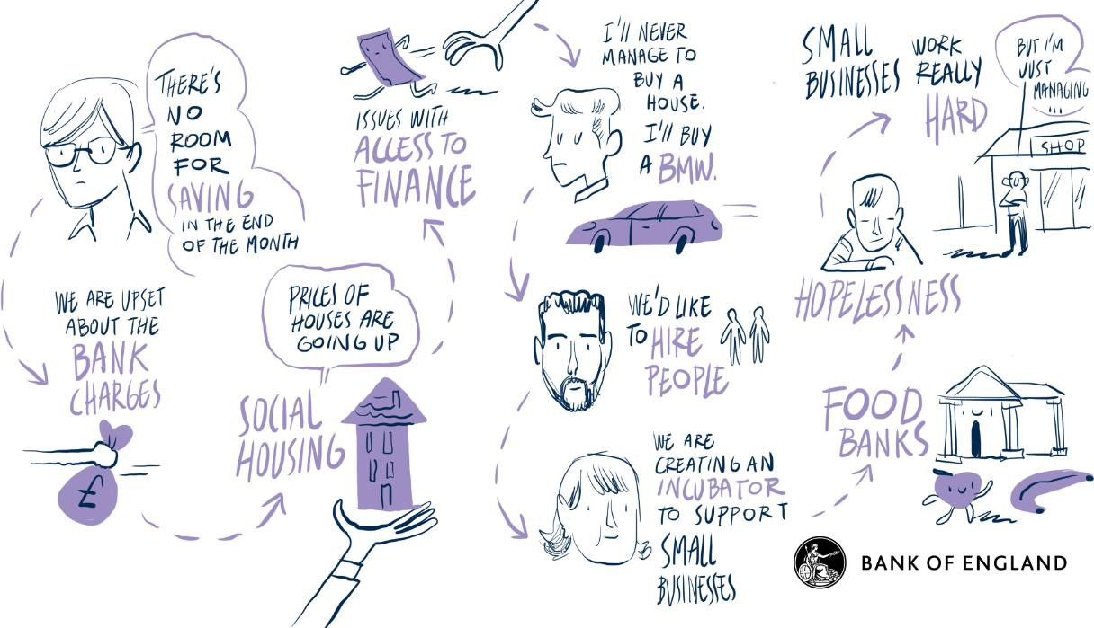

Or this one, on the role of charities in the community from my visit to Leicester.

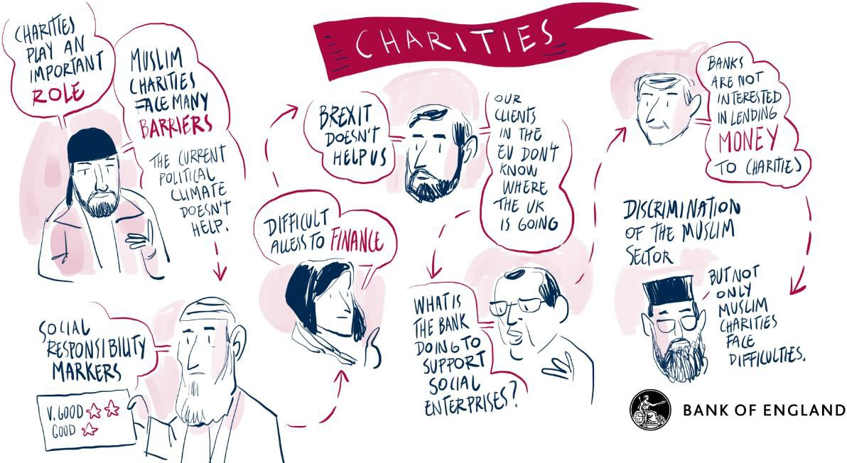

Or this one, on housing and other issues facing young people from my recent visit to Blackpool.

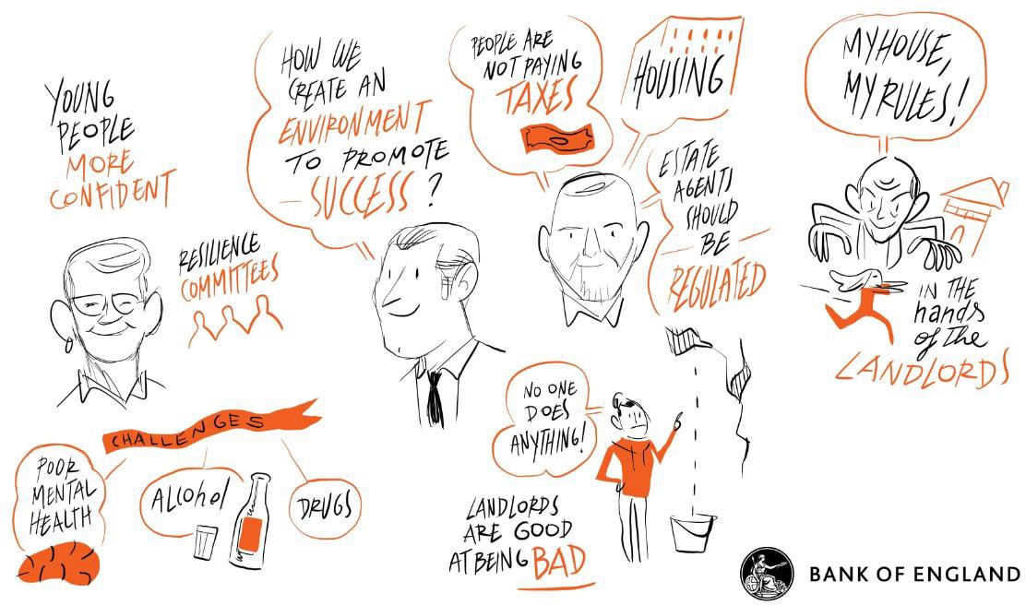

These pictorial narratives provide a simple visual summary which, unlike the written word, can be digested by anyone in less than a minute. They are also a very useful cross-check on my own understanding and a check on my own cognitive biases. Often, I find that the message my non-economist scribe, David, takes from these meetings is different than my own.14 In these situations, I take David’s reading of the room as probably the truer reflection of what citizens have really said.

I call these visits my Townhall Tours, though this is a rubbish description as I have yet to visit a town hall. I am told that anthropologists would call what I am doing “deep hanging out”, after anthropologist

Clifford Geertz.15 Deep hanging out sounds more appealing than visiting town halls. Nonetheless, I am not entirely convinced the Bank of England press release which announces “This is Andy deep hanging out in Stoke” will scan. So I am open to crowd-sourced alternative suggestions.

Let me give one or two concrete examples of how this regional engagement has helped my own understanding of the economy, its hidden corners, its quiet voices.

When UK GDP returned to its pre-crisis peak in 2014 economists told the world the economy had “recovered”.16 Around 30 seconds into a talk about the “recovery” with charities in Nottingham in 2016, I was put straight. The language of recovery resonated with no-one in the room. This experience was repeated on TV, some months later during the referendum debate, when a questioner in Newcastle put straight one of the participants on tonight’s panel with the memorable line “That’s your bloody GDP, not ours”.

14 <http://www.visualscribing.com/>

15 Geertz (1998), with thanks to Grace Blakeley at the Institute for Public Policy Research.

16 The date that real GDP returned to its pre-crisis peak has changed between different vintages of ONS data and was originally thought to have occurred in 2014. In the latest vintage of ONS data, it was in 2013.

When I returned to my desk from Nottingham and plotted GDP regionally as well as nationally, something surprising emerged from the numbers. In fact, GDP had passed its pre-crisis peak in only two regions of the UK – London and the South-East. No other region in the UK had in fact experienced a “recovery”, whether Nottinghamshire or anywhere else. My “recovery” narrative, while true at the national level, had rightly fallen on sceptical ears at a regional level. Although the Bank’s policies only operate at a national level, this is important context for how we and others communicate about the economy.

A second example came when I visited South Wales towards the end of last year. At the time, inflation was picking up as a result of the fall in the pound after the referendum, taking it above its 2% target. But this was a modest inflation overshoot by historical standards, with commensurately modest costs. Or so I thought.

But when people in South Wales described for me its everyday consequences, the costs seemed anything but modest. Their personal inflation rates were running at closer to 10%. For some, that made for a stark choice between “heating or eating”. This made very concrete for me the benefits of the inflation target and monetary policy in supporting people’s everyday lives.

A third example would be the narratives – that word again – I have knitted together from my various regional visits on the structural impediments to growth in communities, towns and cities across the UK. My deep hanging out has, to date, unearthed, six such impediments – the “big six”. They are schooling, housing and shopping, finance, jobs and transport. These are not problems that central banks’ tools can help solve. But any structural plan for the economy worth its salt needs I think to have a song to sing about each of the big six, not just in London and Leeds, Cardiff and Edinburgh, Belfast and Birmingham, but as importantly in Sunderland and Stoke, Blackpool and Bradford, Boston and Orkney.

1. *Citizens Panels*

Last but not least, there is a recommendation in today’s RSA report which is aimed explicitly at the Bank of England. Building on the RSA’s own project, it is that the Bank set up its own set of regional citizen councils, centred around our Agency network. The aim is to establish, in a structured, systematic and comprehensive way, a two-way dialogue and collaboration between the Bank and a panel of citizen representatives on the economy, financial system and policy, as a means of enhancing the understanding of both parties.

This is a bold recommendation. That language would usually preface an official like me lavishing praising on this recommendation, before gently burying it. But not today. I am delighted to announce that the Bank intends implementing in full the RSA’s recommendation. During the course of this year, we will begin the process of setting-up regional citizen councils using our Agency network. This is a natural next step, and will become a central plank, of the Bank’s engagement strategy in the years ahead.

This is, for the Bank, the next rung in our ascent of the engagement ladder. I am confident our view of the economy, and our setting of economic policy, will be greatly enhanced by this wider panorama. It will give

the Bank a new lens on the economy’s hidden corners, a new set of often-quieter voices to listen to and learn from. It is an example of what the Bank, and I hope others, will be doing much more of over the period ahead: listening to a much wider audience, digesting their narratives, and then using this information to support the economy and the citizen stakeholders that make it up.

# References

**Arnstein, S (1969)**, ‘A Ladder of Citizen Participation’, *Journal of the American Planning Association*, Vol. 35, No. 4, pp. 216-224.

**Botsman, R (2017)**, *Who Can You Trust? How Technology Brought Us Together – and Why It Could Drive Us Apart*, Portfolio Penguin.

**England, D, Hebden, A, Henderson, T and Pattie, T (2015)**, ‘The Agencies and ‘One Bank’’,

*Bank of England Quarterly Bulletin*, 2015 Q1.

**Geertz, C (1998)**, ‘Deep Hanging Out’, *The New York Review of Books*, 22 October 1998

**Haldane, A (2017a)**, ‘Everyday Economics’, speech available at <https://www.bankofengland.co.uk/speech/2017/andy-haldane-speech-during-regional-visit>

**Haldane, A (2017b)**, ‘A Little More Conversation A Little Less Action’, speech available at <https://www.bankofengland.co.uk/speech/2017/a-little-more-conversation-a-little-less-action>

**Haldane, A and Turrell, A (2017)**, ‘An interdisciplinary model for macroeconomics’, *Oxford Review of Economic Policy*, Vol. 34, No. 1-2, pp. 219-251.

**Haldane, A and McMahon, M (forthcoming)**, ‘Central Bank Communications and the General Public’,

*American Economic Review, Papers and Proceedings*.

**Kynaston, D (2017)**, *Till Time’s Last Sand: A History of the Bank of England 1694-2013*, Bloomsbury Publishing.

**Tetlock, P and Gardner, D (2016)**, *Superforecasting: The Art and Science of Prediction*, Broadway Books.